# Ground Robots:

The customer requires (Requirement 3) at least a team of two robots working together and one of which should be an aerial robot. The other robot proposed to be used is a ground robot and is to have the following applications:

* Map the area in parallel to the quadcopter
* Serve as a test bed for planning and perception algorithms.

It is proposed that the team will use the TurtleBots from Prof. Nisar Ahmed’s lab. These TurtleBots will have the following hardware specifications:

* iRobot Create
* Guidance
* Odroid XU4
* FLiR
* Asus Xtion Pro (Optional)

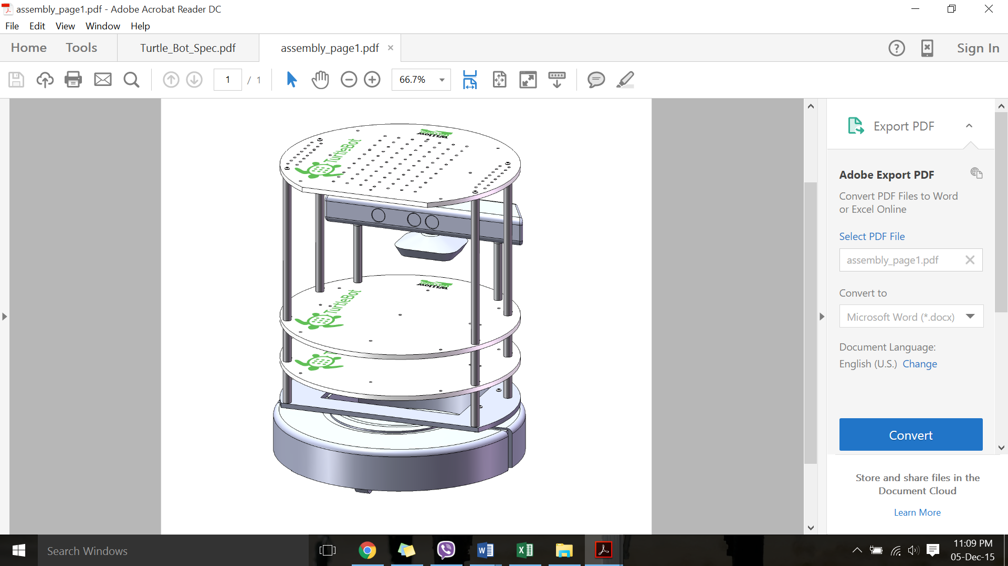

Figure 8:Exsisting TutrleBot

At the moment, the TurtleBots takes goal positions or velocity commands as its input and do not do any mapping on their own. It also relies on the depth image from the Kinect for obstacle avoidance. Hence, it is suggested that we use Hector_Slam using a Hokuyo Laser Scanner.

The hardware block diagram is given below:

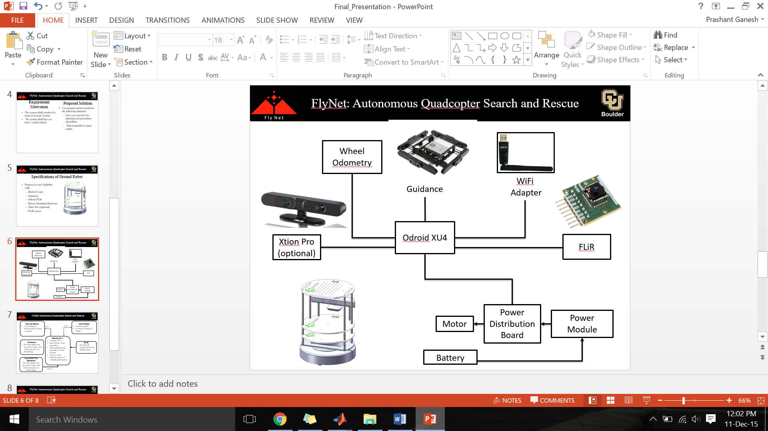

The over system block diagram is given below:

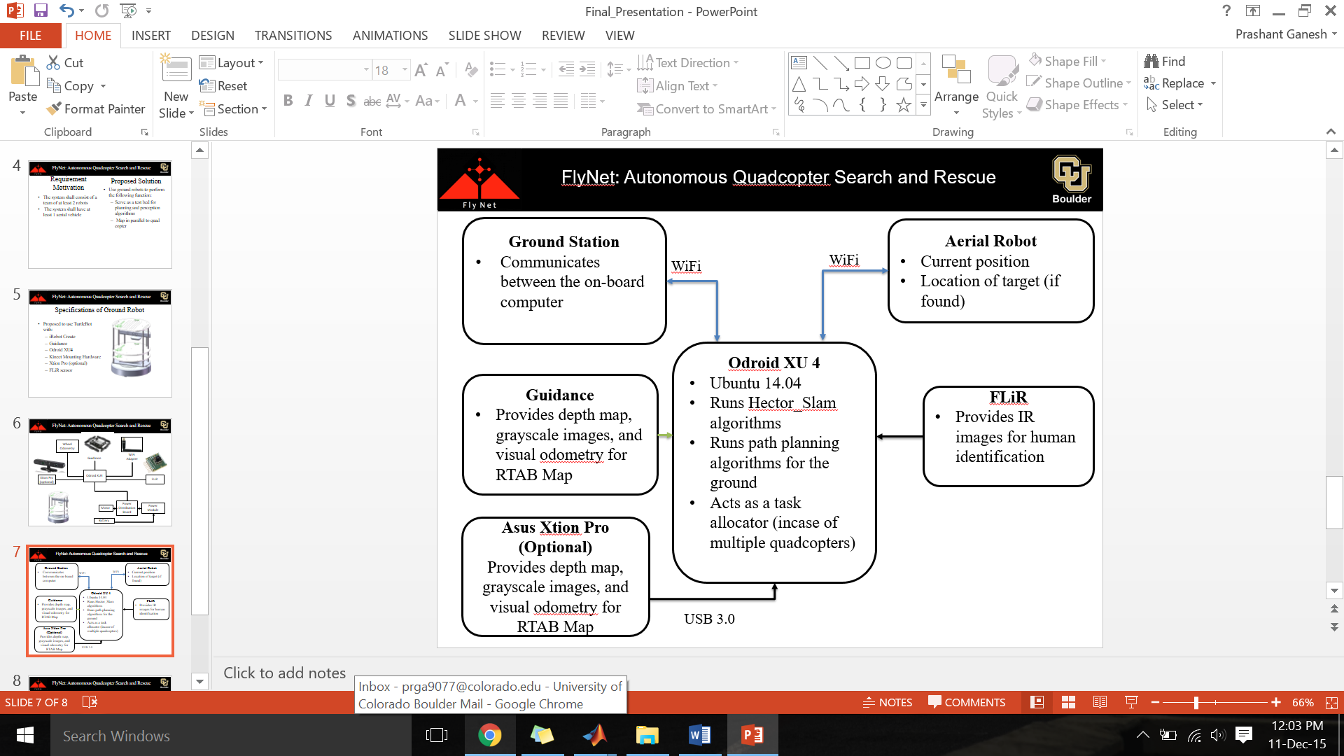

Path Forward:

* Understanding the architecture of the current TurtleBot setup in the COHRINT Lab
* Fabricate additional hardware to accommodate hardware additions
* Implement path planning and perception algorithms
* Integrate with aerial robot